Mongo DB - Complex Queries

Queries from 1-16

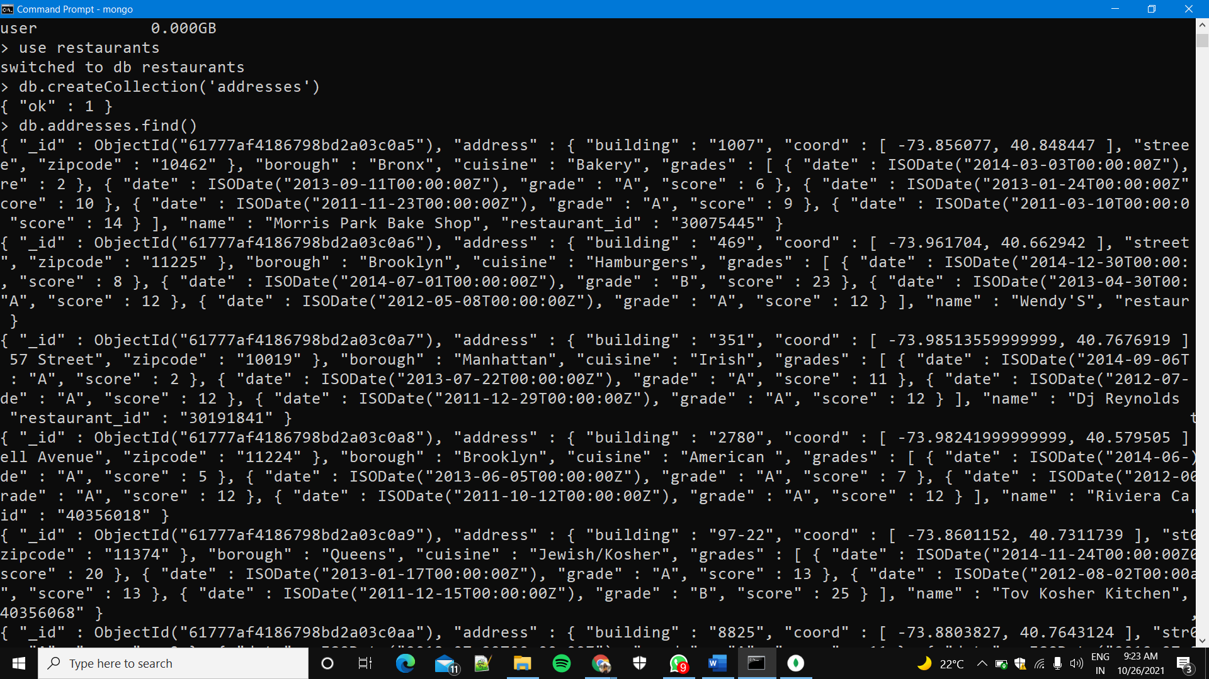

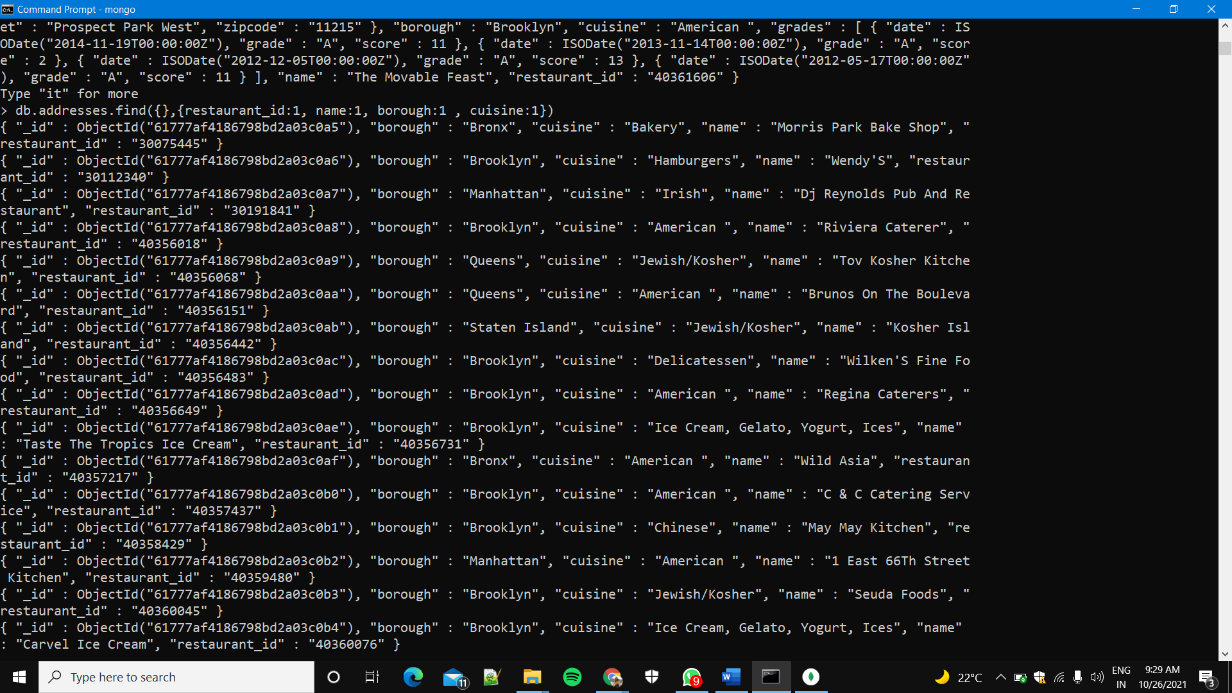

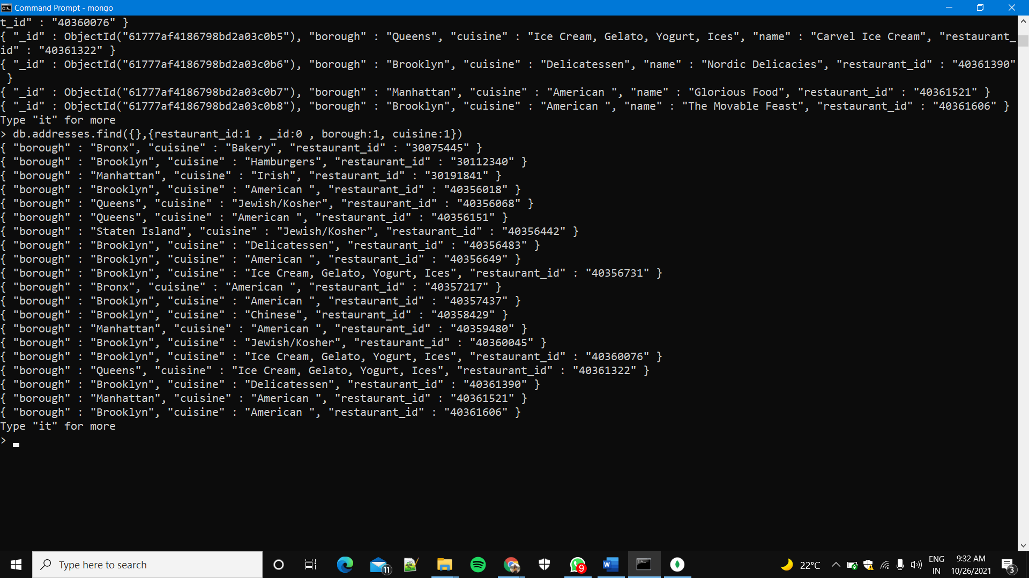

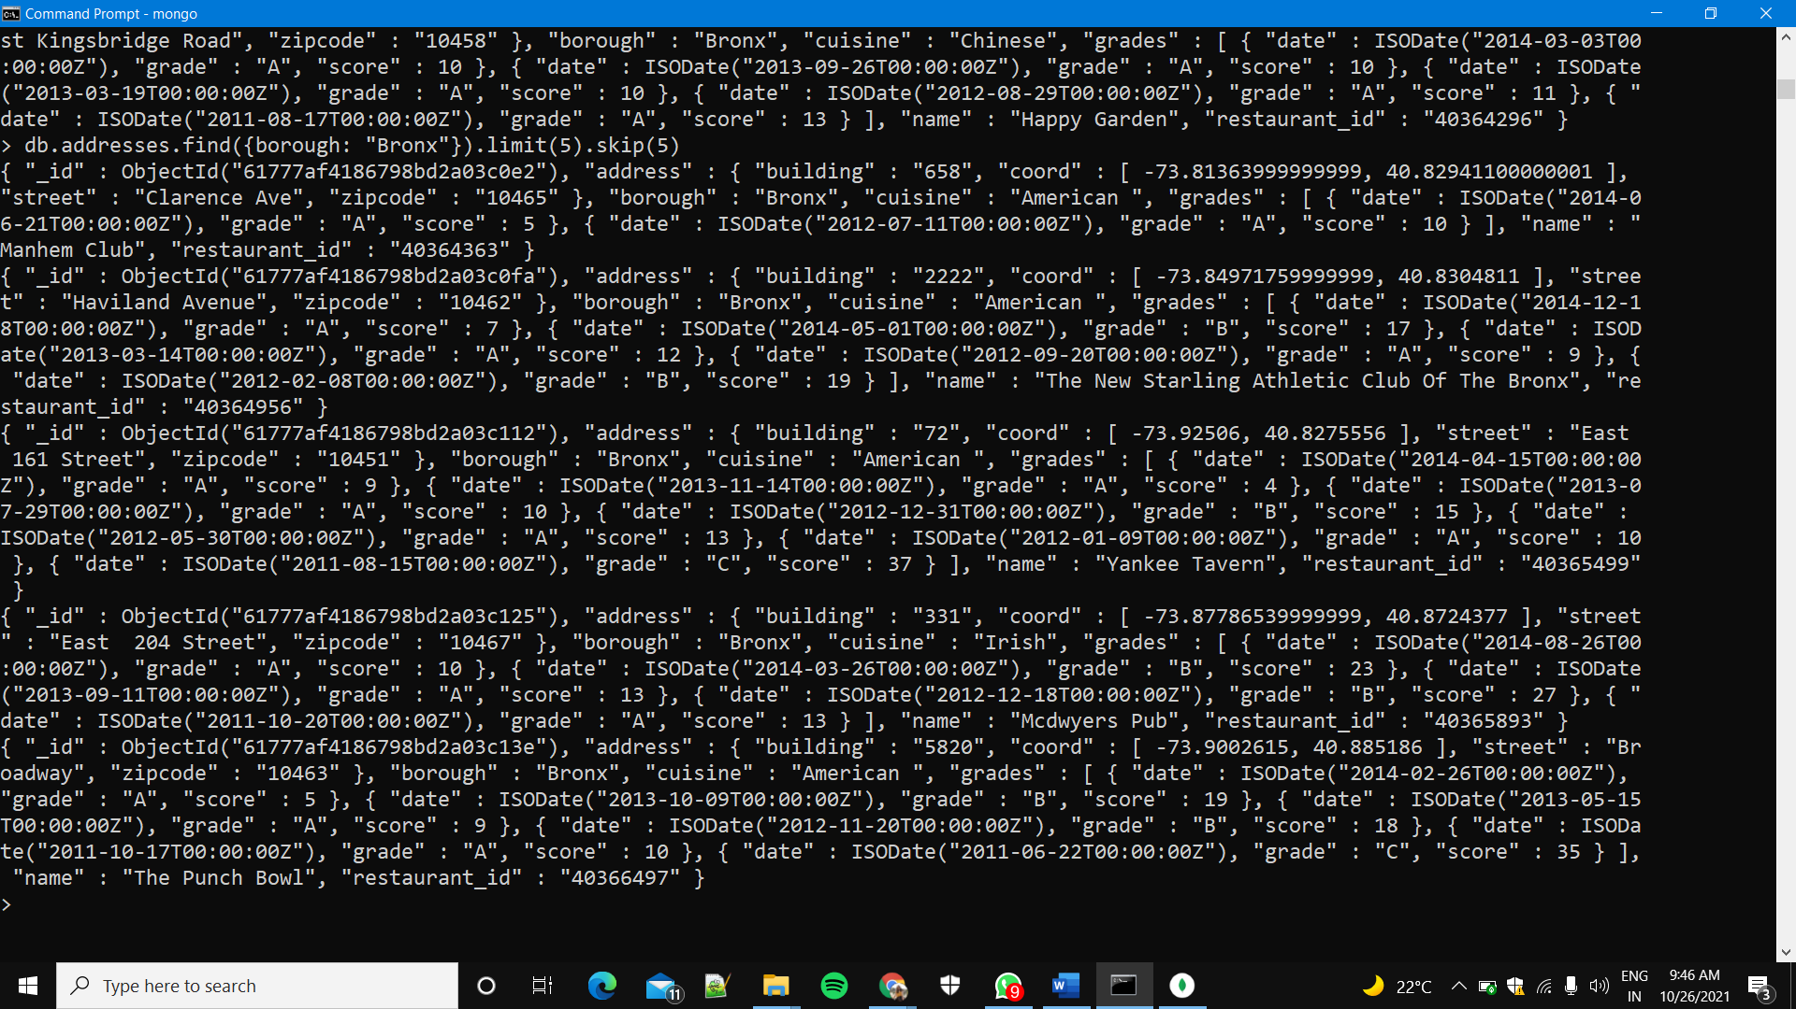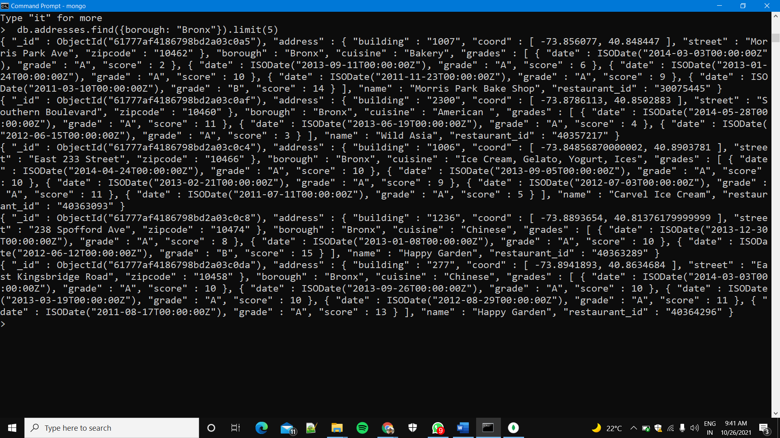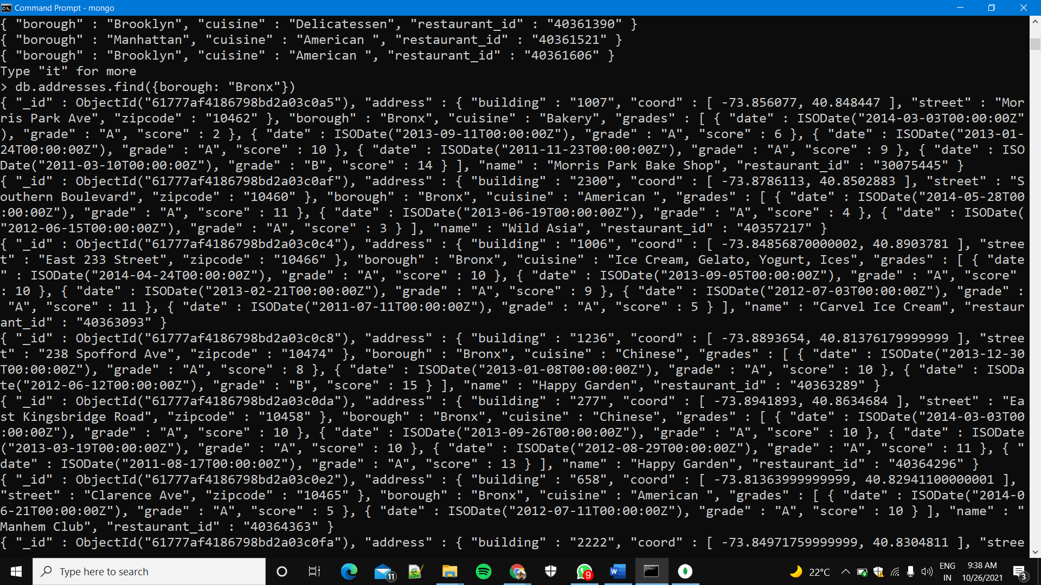

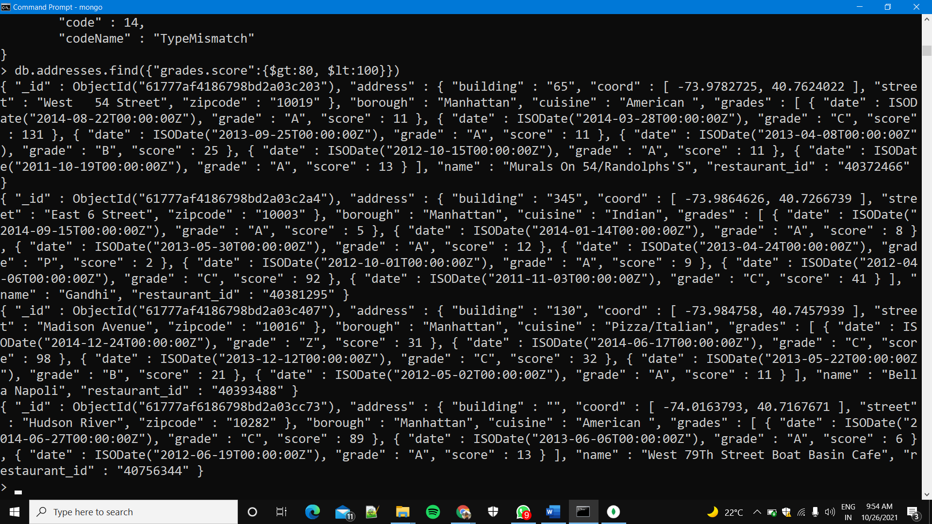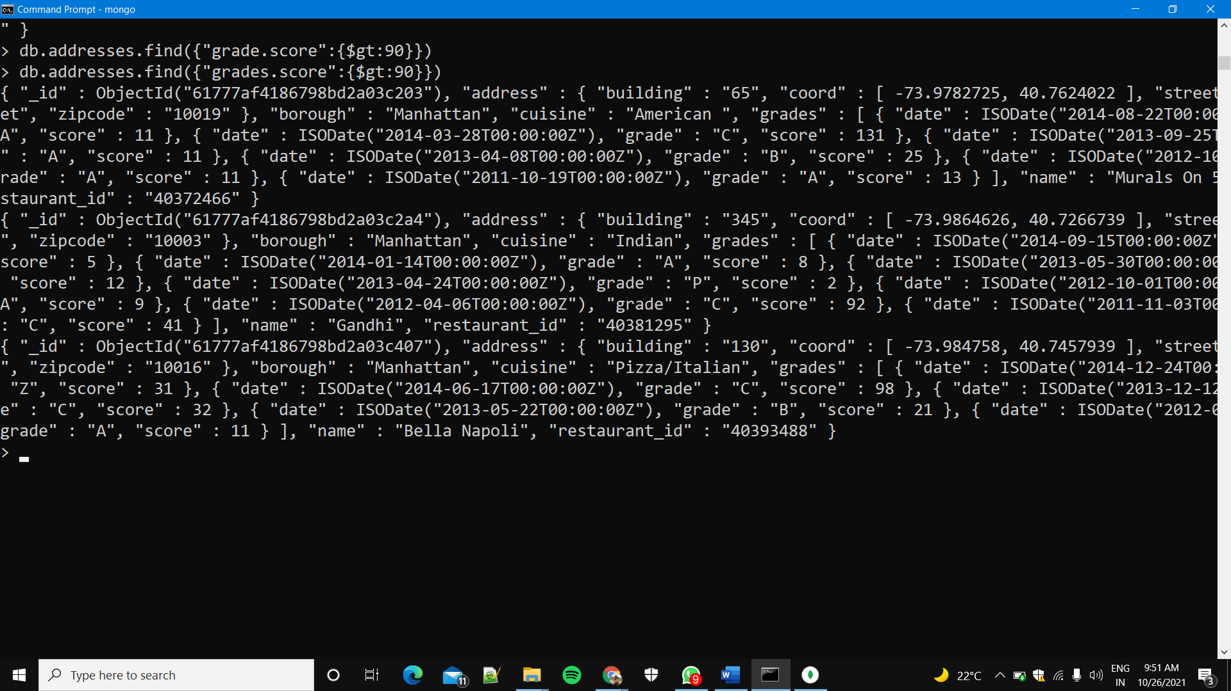

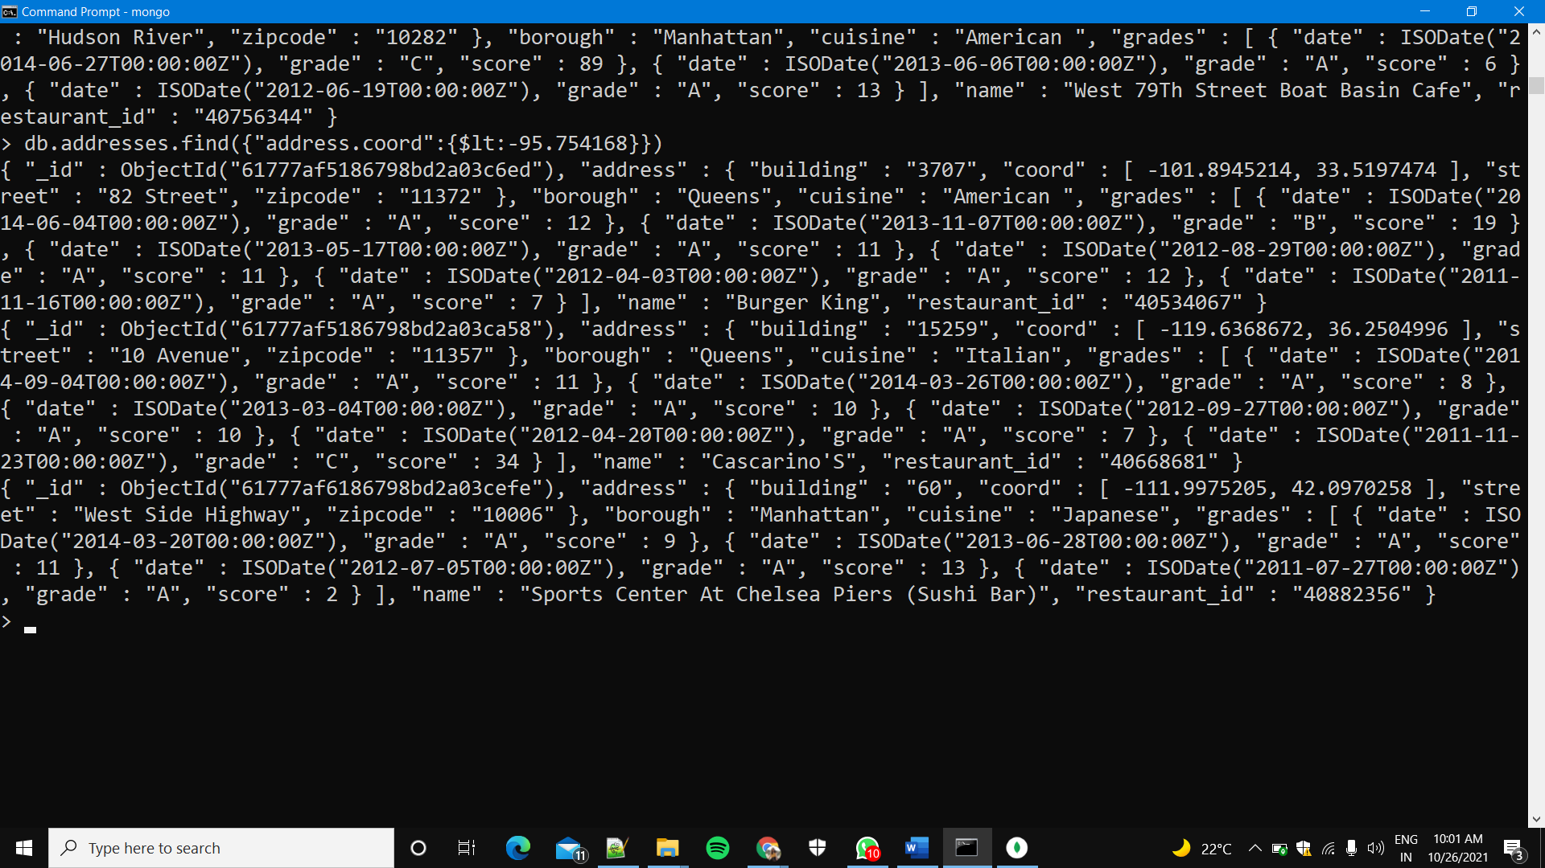

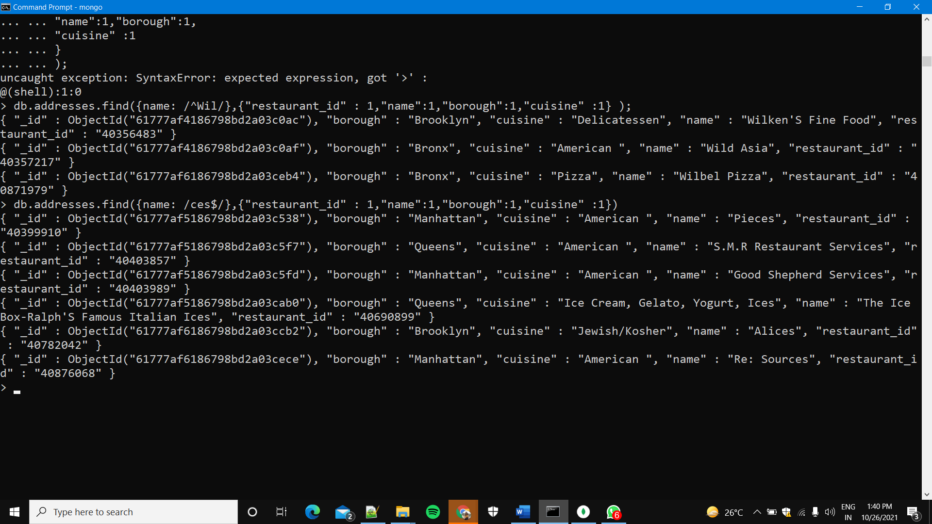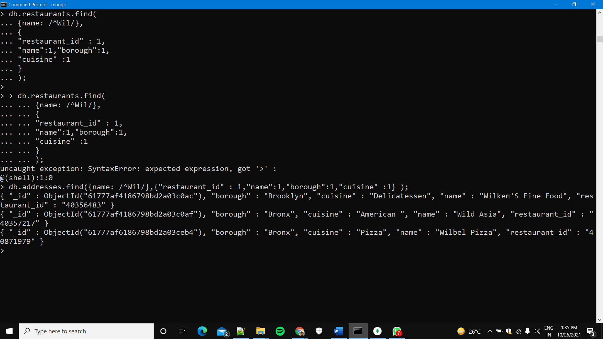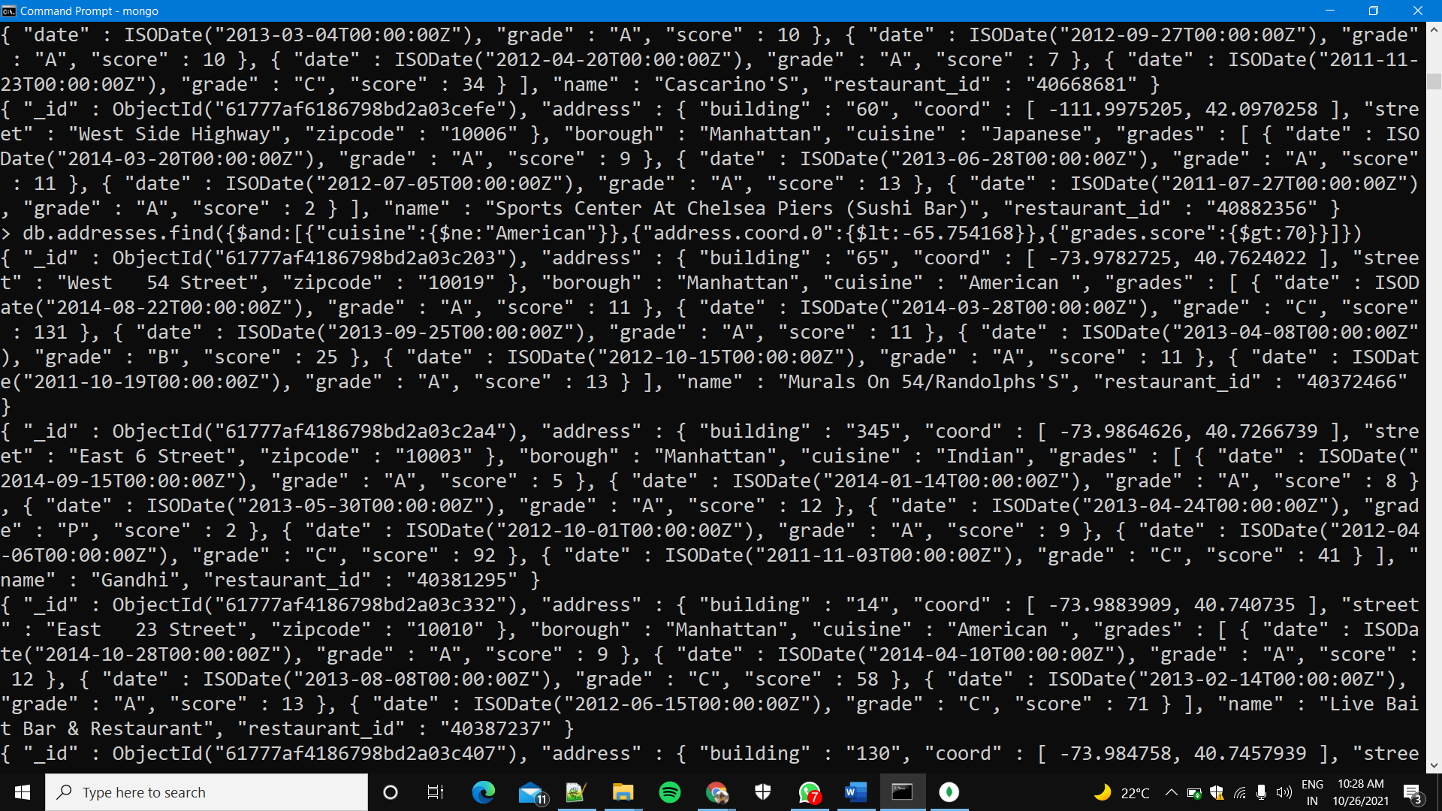

Queries 16-32

16: db.addresses.find({"name": /.*Reg.*/},{"restaurant_id" : 1,"name":1,"borough":1,"cuisine" :1});

17. db.addresses.find({ "borough": "Bronx" , $or : [{ "cuisine" : "American " },{ "cuisine" : "Chinese" }] });

18. db.addresses.find({"borough" :{$in :["Staten Island","Queens","Bronx","Brooklyn"]}},{"restaurant_id" : 1,"name":1,"borough":1,"cuisine" :1});

19. db.addresses.find({"borough" :{$nin :["Staten Island","Queens","Bronx","Brooklyn"]}},{"restaurant_id" : 1,"name":1,"borough":1,"cuisine" :1});

20. db.addresses.find({"grades.score" : { $not: {$gt : 10}}},{"restaurant_id" : 1,"name":1,"borough":1,"cuisine" :1});

21. db.addresses.find({$or: [{name: /^Wil/}, {"$and": [{"cuisine" : {$ne :"American "}}, {"cuisine" : {$ne :"Chinees"}}]}]},{"restaurant_id" : 1,"name":1,"borough":1,"cuisine" :1});

22. db.addresses.find( {"grades.date": ISODate("2014-08-11T00:00:00Z"), "grades.grade":"A" , "grades.score" : 11}, {"restaurant_id" : 1,"name":1,"grades":1});

23. db.addresses.find( { "grades.1.date": ISODate("2014-08-11T00:00:00Z"), "grades.1.grade":"A" , "grades.1.score" : 9 }, {"restaurant_id" : 1,"name":1,"grades":1});

24. db.addresses.find( {"address.coord.1": {$gt : 42, $lte : 52} },{"restaurant_id" : 1,"name":1,"address":1,"coord":1});

25. db.addresses.find().sort({"name":1});

26. db.addresses.find().sort({"name":-1});

27. db.addresses.find().sort({"cuisine":1,"borough" : -1,});

28. db.addresses.find({"address.street" : { $exists : true } } );

29. db.addresses.find({"address.coord" : {$type : 1}})

30. db.addresses.find({"grades.score" :{$mod : [7,0]}},{"restaurant_id" : 1,"name":1,"grades":1}); db.addresses.find({"grades.score" :{$mod : [7,0]}},{"restaurant_id" : 1,"name":1,"grades":1});

31.db.addresses.find({ name : { $regex : "mon.*", $options: "i" } },{"name":1,"borough":1,"address.coord":1,"cuisine" :1});

32. db.addresses.find({ name : { $regex : /^Mad/i, } },{"name":1,"borough":1,"address.coord":1,"cuisine" :1})